CHEM 1021 — Exam 3 Practice Test
Day 4 of 7
Date: ______________________ Score: ________ / 100
Instructions: 25 multiple-choice questions, 4 points each. Choose the single best answer. Give yourself 50 minutes. Use only the reference information below, a periodic table, and a calculator. Fill in the answer sheet on the last page, then grade with the Day 4 Answer Key.
Reference Information
Equations and constants: Molarity = moles solute ÷ liters of solution · M₁V₁ = M₂V₂ · Nₐ = 6.022 × 10²³ · 1 cm³ = 1 mL · 1 L = 1 dm³ · 0.3047 m = 1 ft
The 7 strong acids: HCl, HBr, HI, H₂SO₄, HNO₃, HClO₄, HClO₃. Strong bases: all soluble hydroxide salts.
Common polyatomic ions: ammonium NH₄⁺ · hydronium H₃O⁺ · hydroxide OH⁻ · cyanide CN⁻ · carbonate CO₃²⁻ · phosphate PO₄³⁻ · chlorate ClO₃⁻ · bromate BrO₃⁻ · iodate IO₃⁻ · sulfate SO₄²⁻ · selenate SeO₄²⁻ · nitrate NO₃⁻ · acetate CH₃CO₂⁻
Acid naming: no oxygen → hydro- + root + -ic acid · -ate ion → -ic acid · -ite ion (one fewer O) → -ous acid · one more O than the -ate → per- + root + -ic acid · one fewer O than the -ite → hypo- + root + -ous acid
Activity Series (most → least active; a metal displaces any metal ion listed below it)
Group | Metals | Reacts with
1 | K, Ba, Sr, Ca, Na | Cold water, steam, and acids (produce H₂)
2 | Mg, Al, Mn, Zn, Cr, Fe, Cd | Steam and acids (produce H₂)
3 | Co, Ni, Sn, Pb | Acids only (produce H₂)
— | H₂ | —
4 | Sb, Bi, Cu, Ag, Hg, Pd, Pt | Do not react with water, steam, or acids
Electronegativity (main-group values)
Period | 1 | 2 | 13 | 14 | 15 | 16 | 17
1 | H 2.1
2 | Li 1.0 | Be 1.5 | B 2.0 | C 2.5 | N 3.0 | O 3.5 | F 4.0
3 | Na 0.9 | Mg 1.2 | Al 1.5 | Si 1.8 | P 2.1 | S 2.5 | Cl 3.0
4 | K 0.8 | Ca 1.0 | Ga 1.6 | Ge 1.8 | As 2.0 | Se 2.4 | Br 2.8
5 | Rb 0.8 | Sr 1.0 | In 1.7 | Sn 1.8 | Sb 1.9 | Te 2.1 | I 2.5
Solubility Rules
Ion | Rule | Exceptions
Na⁺, K⁺, NH₄⁺ | Salts with an alkali metal or ammonium ion are soluble | None
NO₃⁻, CH₃CO₂⁻ | All nitrates and acetates are soluble | None
SO₄²⁻ | Most sulfates are soluble | BaSO₄, SrSO₄, PbSO₄, CaSO₄, Hg₂SO₄, Ag₂SO₄
Cl⁻, Br⁻, I⁻ | Most chlorides, bromides, and iodides are soluble | AgX, Hg₂X₂, PbX₂, HgI₂
Ag⁺ | Silver compounds are generally insoluble | AgNO₃ and AgClO₄ are soluble; AgCH₃CO₂ is slightly soluble
O²⁻, OH⁻ | Oxides and hydroxides are insoluble | Alkali metal hydroxides, Ba(OH)₂, Sr(OH)₂; Ca(OH)₂ is somewhat soluble
S²⁻ | Sulfides are insoluble | Compounds with Na⁺, K⁺, NH₄⁺, and alkaline earth cations
CrO₄²⁻ | Most chromates are insoluble | Compounds with Na⁺, K⁺, NH₄⁺, Mg²⁺, Ca²⁺, Al³⁺, Ni²⁺
CO₃²⁻, PO₄³⁻, SO₃²⁻, SiO₃²⁻ | Most carbonates, phosphates, sulfites, and silicates are insoluble | Compounds with Na⁺, K⁺, NH₄⁺

1. Returning Topic: Report the answer to the following calculation with the correct number of significant figures:
(102.5 − 99.8) ÷ (3.141 × 2.00)
A. 0.4
B. 0.43
C. 0.430
D. 0.4298
2. Returning Topic: How many square meters are there in 525 square centimeters?
A. 5.25 × 10⁻⁶ m²
B. 5.25 × 10⁻⁴ m²
C. 5.25 × 10⁻² m²
D. 5.25 × 10² m²
3. Returning Topic: Consider the transition metal chromium (Z = 24). How many d electrons are in the ground-state electron configuration of the Cr³⁺ ion?
A. 1
B. 2
C. 3
D. 5
4. Returning Topic: Which of the following is the correct electron configuration for a neutral iron (Z = 26) atom?
A. [Ar]4s²4d⁶
B. [Ar]4s²3d⁶
C. [Ar]3d⁸
D. [Ar]4s¹3d⁷
5. Tin forms the following compound with chlorine: SnCl₄. What is the name of this compound?
A. tin tetrachloride
B. tin chloride
C. tin(IV) chloride
D. tin(II) chloride
6. Which of the following ionic compounds has the strongest attraction between its ions?
A. MgO
B. CaS
C. NaCl
D. KBr
7. What is the correct chemical formula for diphosphorus pentasulfide?
A. PS₅
B. P₅S₂
C. P₂(SO₄)₅
D. P₂S₅
8. The element quellium reacts with borbium to form a compound with the name quellium hexaborbide. Which of the following statements about this compound is correct?
A. The compound contains six times as many borbium atoms as quellium atoms.
B. Quellium is a metal.
C. Quellium is further right or above borbium on the periodic table.
D. Borbium is a metal.
9. Categorize the following compounds as ionic or covalent.
I: N₂O₅ II: SiCl₄ III: NaH
A. I, II, and III are all covalent.
B. I and II are covalent; III is ionic.
C. I is ionic; II and III are covalent.
D. I and III are ionic; II is covalent.
10. Which of the following bonds is most polar? (Use the electronegativity table.)
A. H–Br
B. H–Cl
C. H–I
D. H–S
11. What is the molecular shape around the atom X in the structure shown?

A. Bent
B. Trigonal planar
C. Tetrahedral
D. Trigonal pyramidal
12. Predict the molecular shape and the approximate bond angle of boron trifluoride, BF₃.
A. Trigonal pyramidal, < 109.5°
B. T-shaped, 90°
C. Trigonal planar, 120°
D. Tetrahedral, 109.5°
13. The formate ion, HCO₂⁻, exhibits resonance. The first resonance structure is shown. Which structure is another valid resonance structure for the formate ion?
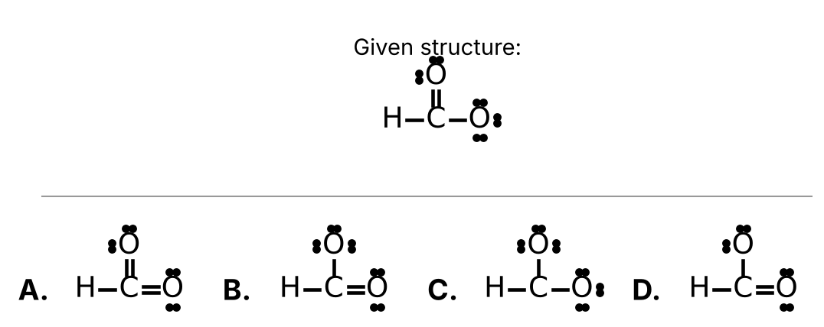
Choose A, B, C, or D from the figure.
14. You prepare an aqueous solution of iron(III) chloride. Which of the following statements about this solution is correct?
A. The solvent is water and the solute is FeCl₃.
B. The solvent is FeCl₃ and the solute is water.
C. The solvent is water and the solute is FCl₃.
D. The solvent is water and the solute is FeCl₂.
15. How many grams of NaCl (58.44 g/mol) are needed to prepare 250.0 mL of a 0.400 M NaCl solution?
A. 0.100 g
B. 2.34 g
C. 5.84 g
D. 5.84 × 10³ g
16. Use the solubility rules to determine which of the following compounds is not soluble in water.
A. AgNO₃
B. NaCH₃CO₂
C. K₂CrO₄
D. Hg₂Cl₂
17. Vornite (Vn) is a fictional non-metal that forms an acid with the formula H₃Vn. What is the name of this compound?
A. Vornic acid
B. Hydrovornous acid
C. Vornous acid
D. Hydrovornic acid
18. Luxium (Lx) is a fictional element that forms the polyatomic ion named luxite with the formula LxO₂⁻. What would be the name of the acid with the chemical formula HLxO₃?
A. Luxic acid
B. Luxous acid
C. Hypoluxous acid
D. Perluxic acid
19. Which of the following soluble compounds when dissolved in water will not create an electrolyte solution?
A. KBr
B. NH₄Cl
C. HClO₄
D. C₂H₅OH
20. Consider the following chemical reaction:
2 KClO₃ (s) —heat→ 2 KCl (s) + 3 O₂ (g)
Which of the following statements about this reaction is incorrect?
A. KClO₃ is the only reactant.
B. There are 3 molecules of O₂ produced for every 2 formula units of KClO₃.
C. The reaction proceeds without any energy input.
D. Oxygen is produced as a gas.
21. Balance the following chemical equation:
C₄H₁₀ (g) + O₂ (g) → CO₂ (g) + H₂O (g) (unbalanced)
How many atoms of oxygen are found on the reactant side when the equation is properly balanced?
A. 10
B. 13
C. 16
D. 26
22. Tetraphosphorus decoxide reacts with water to produce phosphoric acid. Write a properly balanced chemical equation for this reaction. How many water molecules are consumed in this reaction?
A. 4
B. 5
C. 6
D. 10
23. Consider the following chemical reaction:
BaCl₂ + Na₂SO₄ → BaSO₄ + 2 NaCl
This reaction would be classified as a ____.
A. Single Displacement Reaction
B. Double Displacement Reaction
C. Synthesis (Combination) Reaction
D. Decomposition Reaction
24. Which of the following chemical reactions will not occur?
A. Sn (s) + 2 H₂O (ℓ) → Sn(OH)₂ (aq) + H₂ (g)
B. Mg (s) + 2 HCl (aq) → MgCl₂ (aq) + H₂ (g)
C. Zn (s) + FeCl₂ (aq) → ZnCl₂ (aq) + Fe (s)
D. 2 K (s) + 2 H₂O (ℓ) → 2 KOH (aq) + H₂ (g)
25. Complete combustion of a hydrocarbon requires which reactant in addition to the hydrocarbon?
A. CO₂
B. H₂O
C. H₂
D. O₂

Answer Sheet — Day 4
Circle one letter per question.
# | Answer | # | Answer | # | Answer
1 | A B C D | 10 | A B C D | 19 | A B C D
2 | A B C D | 11 | A B C D | 20 | A B C D
3 | A B C D | 12 | A B C D | 21 | A B C D
4 | A B C D | 13 | A B C D | 22 | A B C D
5 | A B C D | 14 | A B C D | 23 | A B C D
6 | A B C D | 15 | A B C D | 24 | A B C D
7 | A B C D | 16 | A B C D | 25 | A B C D
8 | A B C D | 17 | A B C D
9 | A B C D | 18 | A B C D

